**Assisted Practice Project-3**

**Name-Kunal chakraborty**

**package** demo;

**public** **class** Method {

**public** **int** division(**int** a,**int** b) {

**int** c = a/b;

**return** c;

}

**public** **static** **void** main(String[] args) {

Method c1 = **new** Method();

**int** ans = c1.division(50,10);

System.***out***.println("Division of given number: " + ans);

}

}

**Output:**

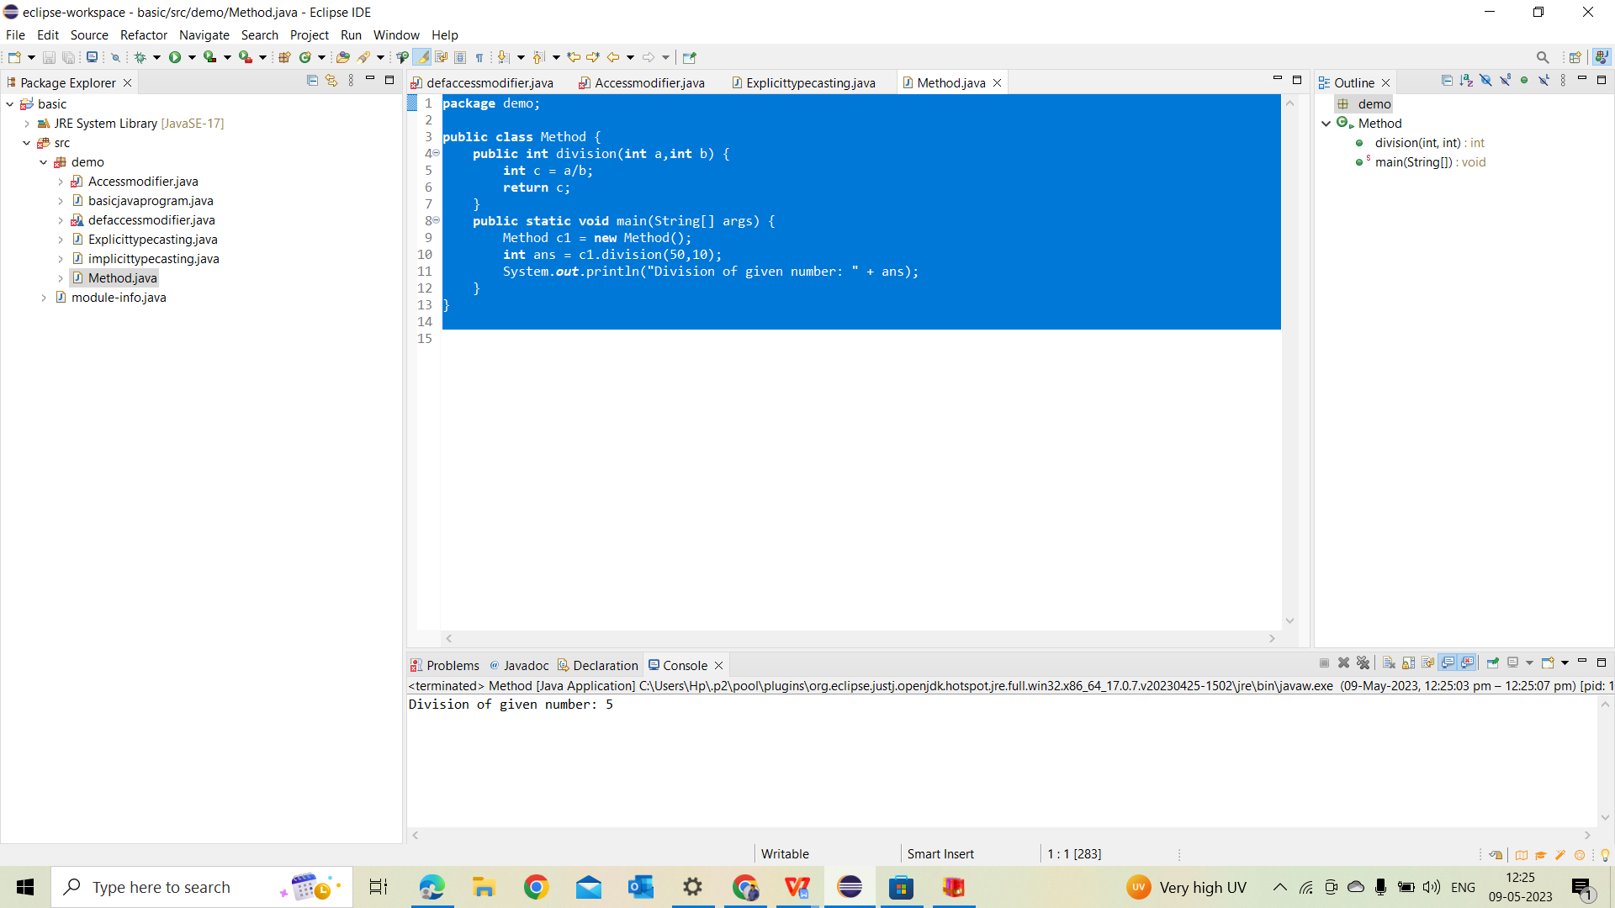

**package** demo;

**public** **class** methodcall {

**int** val=200;

**int** operation(**int** val) {

val =val*5;

**return**(val);

}

**public** **static** **void** main(String args[]) {

methodcall d = **new** methodcall();

System.***out***.println("Before operation value of data is "+d.val);

d.operation(100);

System.***out***.println("After operation value of data is "+d.val);

}

}

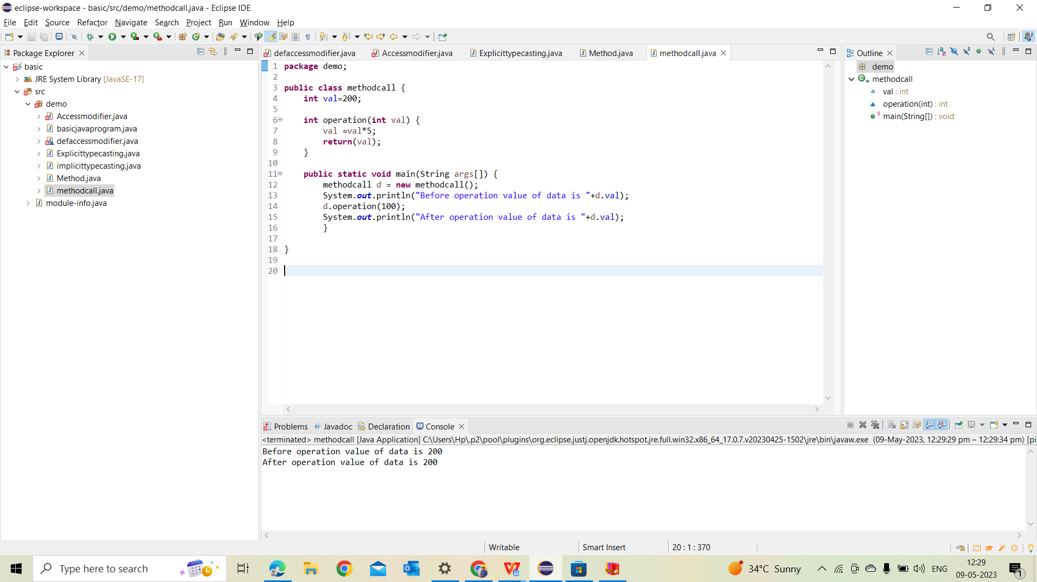

**package** demo;

**public** **class** methodoverloading {

**public** **void** add(**int** a,**int** b) {

System.***out***.println("Addition of two number: " + (a+b));

}

**public** **void** add(**double** a,**double** b) {

System.***out***.println("Addition of two numbers : " + (a+b));

}

**public** **static** **void** main(String[] args) {

methodoverloading d = **new** methodoverloading();

d.add(5, 15);

d.add(8.5, 4.6);

}

}

**Output:**

